Originator:
Name | Job Title | Signature | Date
Andrew Mason | Chief Technology Officer
Approvals:
Name | Job Title | Signature | Date
Nancy Rizzo | Founder and CEO
Scott Pletzer | Director of Quality & Program Management

- Purpose

The purpose of this document is to describe the specifications and design that will be implemented for the Capture Functions in the ClearView system.

- General Requirements

Where appropriate, logic should be contained in try/catch blocks and any exceptions should be logged using the standard logging mechanisms.

- Definitions

ARGB | A defined scheme for the representation of a graphical bit.
File System | The electronic file system located on the ClearView System.

- Specifications

Requirement #4.1: The capture functionality should be available to any authenticated user of the ClearView system.

Specification: The capture functionality will be accessible from the main menu of the ClearView system which will be available to all authenticated users. The user will simply press the menu option button for Capture to begin the process.
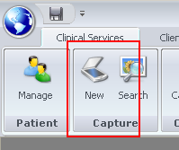
Requirement #4.2: The capture must save the images in a 320 pixel wide by 240 pixel high Bitmap format image.

Specification: All images captured by the system will be captured with a resolution of 320x240 pixels. The color depth will be set to 32 bits per pixel ARGB.

Requirement #4.3: All images must be stored in the SQL server database, not on the file system. The file system can be used for temporary storage or calculations.

Specification: All images will be stored in zipped (compressed) format in a table in the ClearView database called Image.
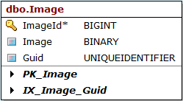
Requirement #4.4: All energized images, lit finger images, raw data and reported final data points are stored in the database. An audit trail will be kept for each datapoint stored in the database constisting of the following tracking points:

  - Id of the user that performed the image capture and initiated analysis.
  - Date and time of the capture/analysis down to the minute.

Specification: The main menu will contain a button that will take the user to a dialog where they can search for existing captures. The button is available to any logged in

Requirement #4.5: A button should be available in the main menu of the application to search for a capture.

Specification: The main menu will contain a button that will take the user to a dialog where they can search for existing captures. The button is available to any logged in user.
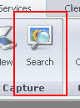

Requirement #4.6: The ability to search for a capture should be available to any authenticated user of the ClearView system.

Specification: The main menu will contain a button that will take the user to a dialog where they can search for existing captures. The button is available to any logged in user.

Requirement #4.7: The user should be able to search for captures using the following criteria in any combination:

- First Name
- Last Name
- Scan Start Date
- Scan End Date

Specification: The capture search dialog that is presented to the user has a number of options that can be used to limit or focus the search that is performed. If the user enters no additional criteria, all records will be shown.

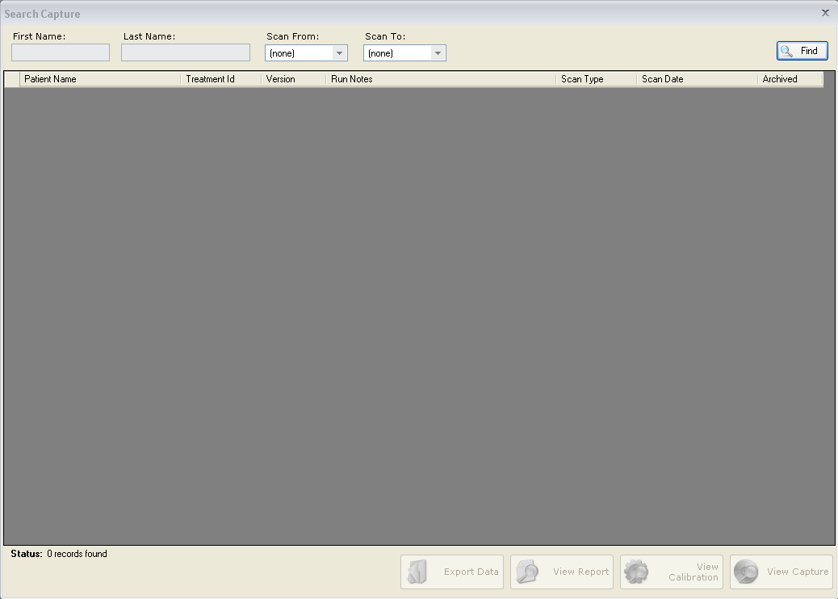

First name and last name can be used together or independently in the search. The search will perform a wild card search; this means that the search will find everything that matches the character typed even if there are more on the end. An example of this would be searching for the first name of “And” would find Andrea as well as Andy as well as Andrew.

A start and or end date can also be entered. If either of these fields are used, scan date is compared to these values to determine inclusion status.

Requirement #4.8: The Scan End Date should default no value.

Specification: The system will set the default Scan End Date to be no value, the only way it will be used in the search is if the user specifies a date.

Requirement #4.9: The Scan Start Date should default to no value.

Specification: The default value for the Scan Start Date on the search dialog is labeled as (none) and treated as an empty value. Scan date will not be used as limiting criteria.

Requirement #4.10: The capture search results should display the following data in columnar format:

- Patient Name (First and Last)
- Treatment Id
- Version of software the scan was run under
- Run Notes- When a scan is resubmitted, the Run Notes column should contain the verbiage: “Reprocessing of Treatment Id: XXXX”
- Scan Type
- Scan Date- When a scan is resubmitted, the original date of the scan should be saved and displayed in the ‘Scan Date’
- Archived Flag

Specification: The search results are displayed in columnar format with the columns matching the requirements described above.

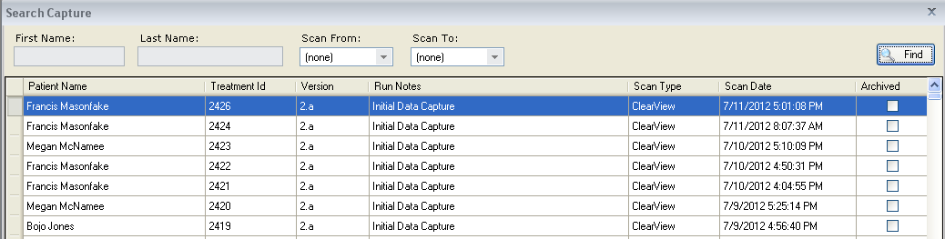

The columns listed in the display are Patient Name, Treatment Id, Software Version, Run Notes, Scan Type, Scan Date and Archived. All matching records are displayed, if necessary a scroll bar is added to the display to denote that there are more records.

Requirement #4.11: The default sort order of the list will be by date scanned in descending (most recent first) order.

Specification: The default sort order for the search results dialog is by Date Scanned, listed in descending order. The default sort order can be seen by examining the data or locating the triangle that appears in the column header next to the column that is sorted.
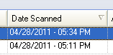
Requirement #4.12: The search results list should be able to be sorted by any of the columns that are displayed in either ascending or descending order.

Specification: The grid that displays the search results can be automatically sorted by any of the columns that appear in the grid. To sort the display, simply click on the header that should drive the sort. Clicking multiple time on the same column will change the order sorted from ascending to descending and vice-versa.

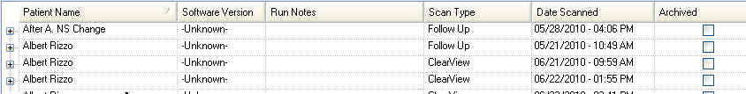
Requirement #4.13: Four functions should be able to be performed from the capture search results dialog:

- Viewing the Report Pages
- Viewing the Calibration Set Images
- Viewing the Capture Images
- Exporting of the subjects information including:
  - Finger Images
  - Calibration Images
  - Raw Calculated Data
  - Report Data
  - Calibration Data

Specification: The search results dialog contains three buttons that represent access to the functionality described in the requirement.
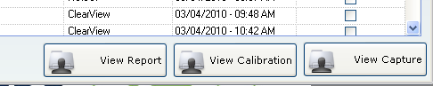

Requirement #4.14: Clicking the view report button will load the report data for the selected patient and capture in the search results grid.

Specification: Clicking the View Report button will load the report data for the selected patient and capture in the search results grid. The report specifications are contained in another document.

Requirement #4.15 Clicking the view calibration button will display a dialog containing the Calibration images used during the selected scan.

Specification: Clicking the View Calibration button will display a dialog containing the Calibration images used during the selected scan. The specifications of this dialog are listed further below in this document.

Requirement #4.16 Clicking the view capture button will take the user to a dialog containing the images from the capture that was selected in the search results.

Specification: Clicking the View Capture button will take the user to a dialog containing the images from the capture that was selected in the search results. Specifications for the dialog are contained further down in this document.

Requirement #4.17 Clicking the view export data button will present the user with a directory search dialog box which will allow them to specify where the export data will be saved for the selected subject.

Specification: The button shown below was added to the capture search dialog.

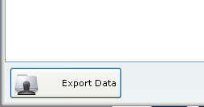

Clicking this button will cause a folder dialog to display allowing the user to select where the export data will be written. The data will be written into a folder structure as show below in the parent folder selected:

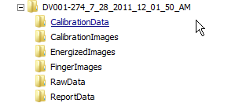

Each folder will contain the described relevant data, in some cases images in other cases csv format files containing data.

New Capture

Requirement #4.18: A new capture button should be available in the main menu of the application to initiate a new capture.

Specification: A button appears in the main menu to being the process of initiating a new scan.
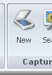
Requirement #4.19: A new capture can only be taken if the calibration routine has been successfully completed within the past 24 hours, and no more than 4 hours have elapsed since the last capture. If these are not true the calibration process must be run again.

Specification: When the option to perform a new scan is selected from the main menu, a check is performed to determine if the system requires a calibration to be run. The function called is MustCalibrateCamera and accepts a customer Id as the single parameter. The function returns a Boolean, true if the camera must be calibrated and false if not.
The function first checks to see if more than 24 hours have elapsed since the last time the scanner was calibrated. If this is true then the function stops and returns the value of true.
If the first check is passes without the need for calibration, the function will then check to see if a scan has been performed in the last 4 hours, if not the function returns true.

Requirement #4.20: The new capture process must allow the user to select the patient from the system that the capture is being performed on.

Specification: When the new capture button is pressed, the user us presented with the patient search dialog. This dialog will let the user find the patient the scan is going to performed on. If the patient is not in the database
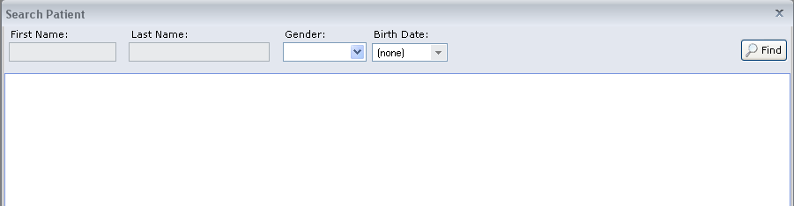
Requirement #4.21: The user can be located by searching on the following criteria or any combination thereof:
- First Name
- Last Name
- Gender
- Birth date

Specification: The search dialog as show above has the option for each of the fields listed in the requirement to be populated with data to limit the search. None of the fields are mutually exclusive.

First name and last name can be used together or independently in the search. The search will perform a wild card search; this means that the search will find everything that matches the character typed even if there are more on the end. An example of this would be searching for the first name of “And” would find Andrea as well as Andy as well as Andrew.

Requirement #4.22: The patient must first be searched on before a “New Patient” button will appear in order to prevent duplicate entry of patients.

Specification: A new patient button appears that the bottom of the patient search results dialog box, after a search is performed.
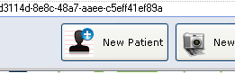
Requirement #4.23: The search results page should contain the following elements:

- First Name
- Last Name
- Gender
- Patient Id
- Archived Flag

Specification: The patient search results dialog contains the fields specified in the requirements. All records matching the criteria are returned, if there are more than will fit in the dialog box, a scroll bar will appear in the search results.
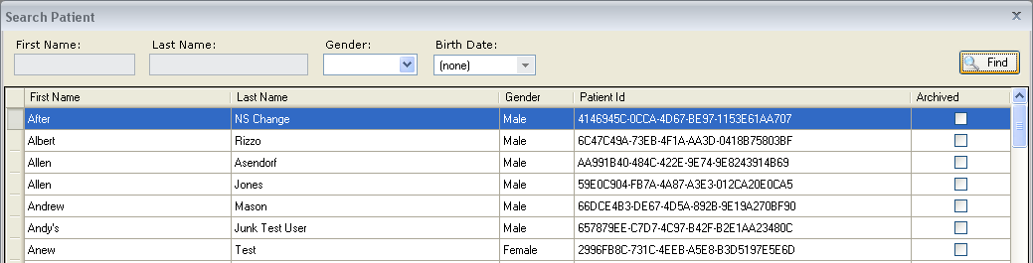
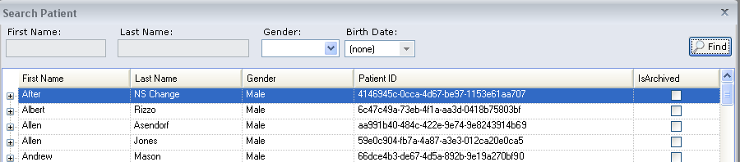
Requirement #4.24: The default sort on the new capture search results page will be first name.

Specification: The default sort for the dialog is the Patient Name, there is no ability to dynamically sort on this page.

Requirement #4.25: The search results page should have buttons for three options available:
- Create a new Patient
- Get a new capture for the selected patient
- View the selected patient's demographics

Specification: The Patient Search results dialog has three buttons that appear at the bottom of the page, they map to the buttons specified in the requirements.
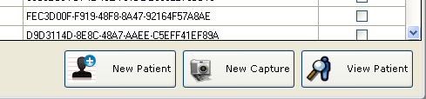
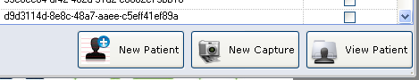

Requirement #4.26: Clicking on the ‘New Patient’ button will take the user to the section of the application where patients are added to the system.

Specification: Clicking on the 'New Patient' button will take the user to the section of the application where patients are added to the system. This functionality is documented in another requirements document.

Requirement #4.27: Clicking on the new capture button will take the user to the new capture dialog for the selected individual.

Specification: Clicking on the New Capture button will take the user to the new capture dialog for the selected individual. The specifications of this dialog are listed further down in this document.

Requirement #4.28: The new capture dialog should allow the display of twenty thumbnail images. These will consist of one image per finger for both hands, once for filtered and once for unfiltered.

Specification: All collected images can be seen on the bottom of the dialog. The unfiltered images appear above the filtered images, clicking on any image will display the full size version of the image.
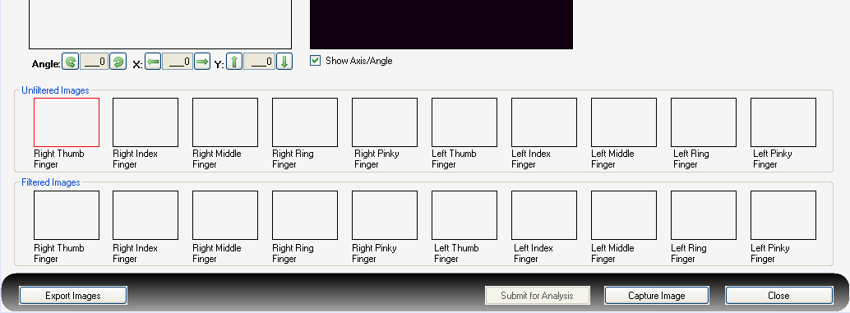
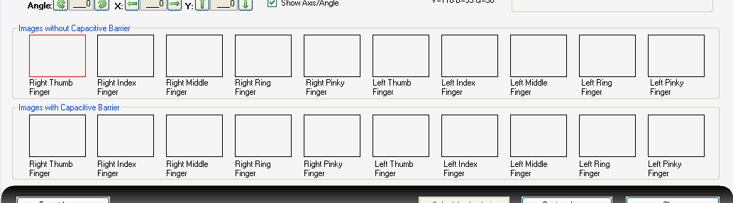
Requirement #4.29: The dialog should display a live preview window which will show a live image of the finger before the energized image is captured.

Specification: The capture dialog contains a live preview window that will show the lighted finger image, this will aid in finger positioning. The preview window will then contain a still image of the captured finger until the next finger is selected.
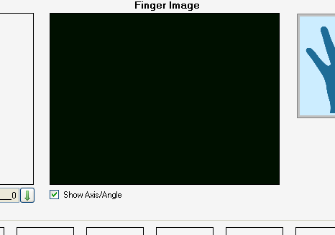
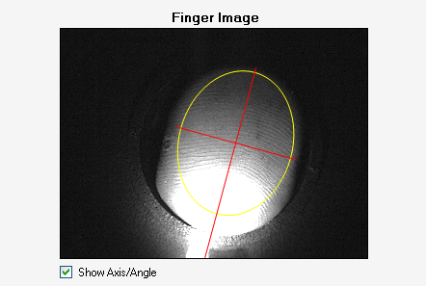

Requirement #4.30: The dialog should show the captured bitmap image after the capture sequence has taken place.

Specification: Once an energized image has been captured, the static finger image that goes along with it will appear in the Finger Image window.

Requirement #4.31: The dialog should have information/messaging area on it so that messages can be displayed to the user as necessary during the capture process.

Specification: A message area appears on the capture dialog. This area will inform the user of any important messages or facts as well as tell the user about progress.
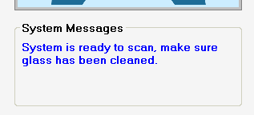
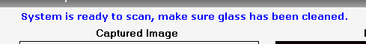
Requirement #4.32: The dialog should display a graphical representation of which finger is currently being scanned, as an orientation and verification point to the user.

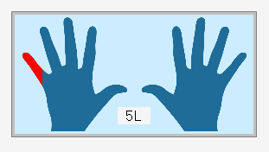
Specification: A graphical view of two hands has been created and will be used to display what finger is currently being scanned. The finger being scanned on the hand will be highlighted in red and the short name of the finger 5L (Which represents then Pinky finger on left hand) will be displayed.

Requirement #4.33: The currently selected image should have a red border around the thumbnail image.

Specification: The currently selected thumbnail for the finger to be scanned will be bordered in red to represent that it is the currently selected finger.
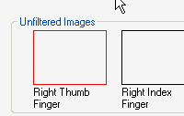
Requirement #4.34: The system should automatically calculate the angle of the image as well as the center point of the captured image.

Specification: As soon as an image is captured, a set of calculation are performed on it to determine amongst other things the angle of the image. The calculation performs a shape analysis to determine the vertical axis angle. The value of the angle is returned to the software and placed in a field labeled Angle.

Requirement #4.35: The system should draw an oval around the calculated edge of the image.

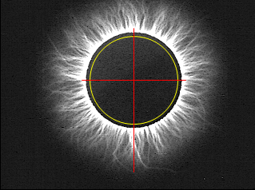
Specification: Calculation is performed in order to determine the center point of the image as well as the general shape of the image. This information is then used to illustrate the inner edge of the image.

Requirement #4.36: The system should display the angle of the image by drawing a line along the Y axis through the midpoint along the calculated angle. The line should start a few pixels above the drawn oval and extend below the drawn oval for a distance greater than that above the drawn oval.

Specification: The system will draw a vertical and horizontal axis on the image to illustrate the calculated angle of the image. The line will start a few pixels above the drawn oval and end approximately 50 pixels below the calculated oval.

- Requirement #4.37: The system should draw a line along the X axis through the midpoint along the angle calculated + 90˚. The line will extend slightly beyond the drawn oval.

Specification: The system will draw a vertical and horizontal axis on the image to illustrate the calculated angle of the image. The line will be drawn along the X axis through the midpoint along the angle calculated + 90'.The line will run from approximately 5 pixels to the right of the calculated oval to 5 pixels to the left of the calculated oval.
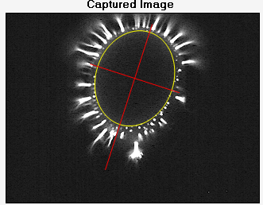
Requirement #4.38: The oval and lines described above should be placed over the energized image as well as the finger image.

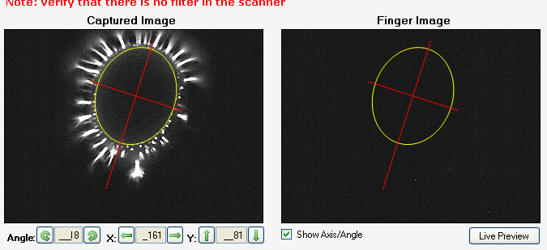
Specification: The same geometric shapes (oval and cross airs that appear over the energized image will also appear over the finger image. This is to help the user verify the proper angle calculation of the image.

Requirement #4.39: Fields should be available on the dialog to edit the angel, the x coordinate and the y coordinate calculated by the system. The calculations must be able to be overridden.

Specification: Fields containing the angle of the image, the x coordinate of the center of the image and the y coordinate of the center of the image, are displayed. The user is able to edit any of these fields as they see fit.
Any change to these fields will cause the oval and cross airs to be redrawn in accordance with the new data.

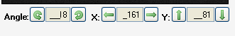
Requirement #4.40: If the calculated values are overridden, the center point and angle generated by the user must be reflected in the axis and oval that are generated over the images.

Specification: See #4.35.

Requirement #4.41: There should be an ability to turn on and off the oval and cross air on the images.

Specification: A check-box has been added that will determine if the oval and cross airs are drawn. The check-box will be defaulted to checked, causing the graphics to be drawn. The check-box can be toggled at will during operation to turn the graphics on or off.

Requirement #4.42: The user should be able to select the image to capture by clicking on the thumbnail; this will make the clicked thumbnail the active capture point.

Specification: The user can at any time click on any of the thumbnail containers to make the selected one the active thumbnail. This will cause the next captured image to be placed in the thumbnail and be indexed to the selected finger.

Requirement #4.43 When a capture takes place, both the captured finger image as well as the captured energize image will display in the full size boxes. The energized image will also appear in the selected thumbnail.

Specification: Until the next finger is selected, both the energized image as well as the captured finger image are displayed side by side in the full size image boxes.
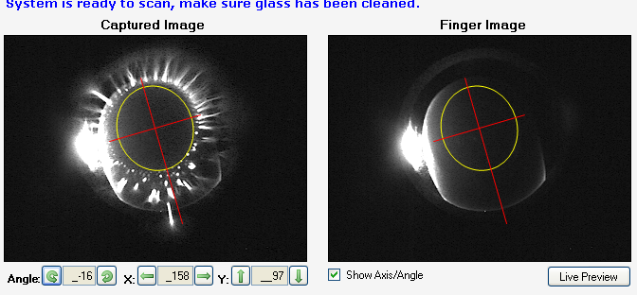

Requirement #4.44: There should be a button to allow the user to return to the live preview in the case where the captured image must be re-captured.

Specification: A new button was added below the Finger Image full size image box that toggles the box between a static view of the captured image and a live view. The button is labeled “Live Preview”, it only appears when a static image is displayed. Pressing this button returns the picture box to the live preview.

Requirement #4.45: The user can select a thumbnail at any time to display both the finger image and energized image that was captured.

Specification: Clicking on a thumbnail that already has an image in it will cause the image to be displayed in full size; the finger image will also be displayed.

Requirement #4.46: Three action buttons will always be displayed for the user at the bottom of the dialog:

- A Close button – This will simply close the dialog.
- A Capture Image button – This button will begin the capture process for the selected image.
- A Submit for Analysis button – This button will submit the images collected to the analysis engine to perform the necessary calculations. The button will remain disabled until all 20 images have been successfully collected.

Specification: Three buttons appear at the bottom of the dialog, as specified in the requirement.
- The Close button will appear and will always be enabled with the exception of when an analysis process is running. Clicking the close button will close the dialog.
- The Capture Image button will be available until the analysis process is started. Clicking the capture button will capture both a finger and energized image and display them on the dialog.
- The Submit for Analysis button will only be available once all 20 images have been captured. Pressing this button will begin the analysis process and temporarily disable all other buttons.

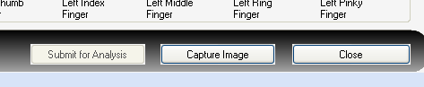
Requirement #4.47: An additional button 'Export Images' will be available only to EPIC system administrator users 'administrator'. This button will allow the user to export both the energized and finger images to the file system before an analysis is run.

Specification: A button will appear in the lower left corner of the capture dialog for the 'administrator' user only. This button will allow the user to export both the energized images as well as the finger images.
Clicking this button will prompt the user to select a directory where the images will be exported and then it will save all of the available images to that location.

Requirement #4.48: The 'administrator' user may also right click on a thumbnail to manually load an image from the file system. Right clicking on a thumbnail will cause an open file dialog to appear that will allow the user to select an energized image. No finger image will be loaded.

Specification: For the administrator user only, right clicking on the thumbnail images will cause a file load dialog to display. The dialog by default will limit the user to seeing only image files that match the naming convention for the finger they are looking for. When a file is selected it will be loaded into the thumbnail that was clicked as well as into the full size image display. The appropriate calculations will also be run on it to determine midpoint and angle.

Requirement #4.49: The settings for the camera including the configurable values of voltage, brightness and gain should be displayed.

Specification: The values for voltage brightness and gain for the current camera configuration are displayed directly below the live preview window.

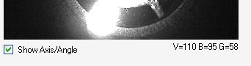

Requirement #4.50: The ability to turn on and off the display of the centerpoint of the image and the angle of the image must be available.

Specification: A checkbox is added that will allow the operator to toggle the centerpoint and angle display on or off. This can be done at any time during the scanning process. If the option is turned off, the angle and centerpoint will still be captured and stored.

View Capture

Requirement #4.51: The view capture dialog should allow the display of twenty thumbnail images. These will consist of one image per finger for both hands, once for filtered and once for unfiltered.

Specification: The view capture dialog will show all 20 images for a capture in the same manner as the new capture dialog. The unfiltered images will be shown on top and the filtered images below them.
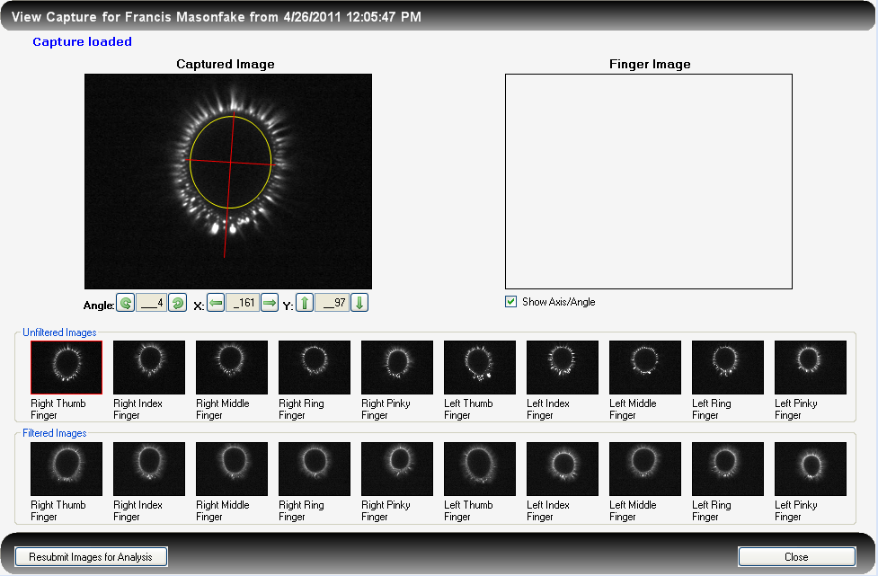
Requirement #4.52: The dialog will be loaded with the energized images from the data for the patient that was selected. Although there will be a placeholder for a large finger image, this will remain blank since finger images are not currently persisted.

Specification: The view capture dialog loads with all of the energized images loaded. The image angles as well as the midpoint are also loaded prior to the dialog being displayed.

Requirement #4.53: The system should display the saved angle as well as the midpoint values.

Specification: The image angles as well as the midpoint are loaded from the database prior to the dialog being displayed. These values can be seen when viewing each individual image.

Requirement #4.54: There will be one button available to the user, 'Close'. This button will close the dialog and take the user to the main menu.

Specification: The close button appears on the lower right corner of the dialog box. Clicking this button will close the dialog and take the user back to the main menu.

Requirement #4.55: The ability to view the calibration will be available to any authenticated ClearView user.

Specification: A button will be available at the bottom of the Search Capture dialog that will take the user to a dialog where the calibration images can be viewed for the selected capture record. The button is available to all system roles.
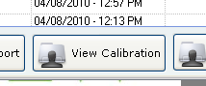
Requirement #4.56: The dialog that appears will display thumbnail images of all ten calibration images that were used for the selected scan.

Specification: A dialog that matches in general appearance to the capture and view capture dialogs. The difference is that this dialog will only have one full size picture and ten thumbnails.
Since these are calibration images, we do not have finger images and we only have ten images rather than twenty.

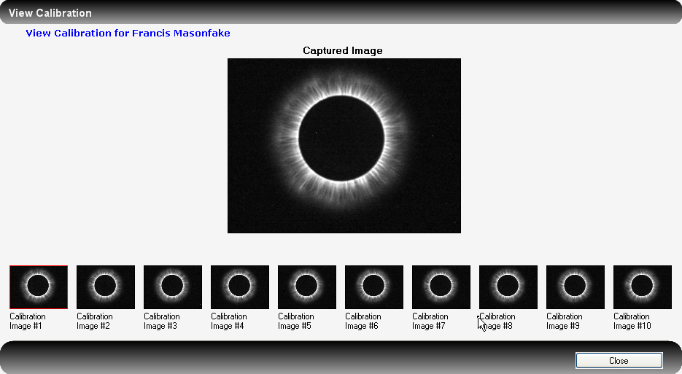
Requirement #4.57: A full size image (230 x 240) will be displayed in the middle of the dialog.

Specification: A full size picture box exists above the thumbnail images as can be seen in the image from requirement #47.

Requirement #4.58: Clicking on the individual thumbnail images will cause the image clicked to display in the full size image area, allowing the user to see a full size image of any of the thumbnails.

Specification: When the user clicks on a thumbnail image, the full size version of the image is displayed in the full size image picture box.

Requirement #4.59: The image that is currently displayed in the fill size image box in the middle of the dialog will have a thumbnail image bordered in red.

Specification: The border of the selected image will always be displayed in red.
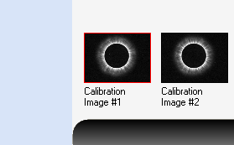
Requirement #4.60: The patient name will appear at the top of the dialog.

Specification: The name of the patient appears in the information line at the top of the dialog box displaying the calibration images.
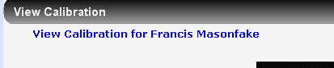
Requirement #4.61: A single button will appear on this dialog, it will be labeled “Close” and will close the dialog and take the user back to the main menu.

Specification: A single button appears at the bottom of the dialog, pressing this button will close the dialog and take the user back to the main menu.

Document Revision History
Version Number: | Description of Change: | Date: | Updated by:
000 | Introduction | 5/24/11 | A. Mason
001 | Update requirement #12 to reflect new requirements documented in version 001 of SR-202. These new specifications provide functionality to:  - Export data in the Search Capture function  - and allow EPIC Administrator users to Resubmit data for analysis | 8/31/11 | A. Mason
002 | Modify Search Capture (Requirement #9) to match current existing requirements. Update verbiage of Specification #9 to current software performance. Added Definitions section. | 3/5/12 | A. Mason
003 | Aligned specifications with requirements document. | 7/18/12 | A. Mason

